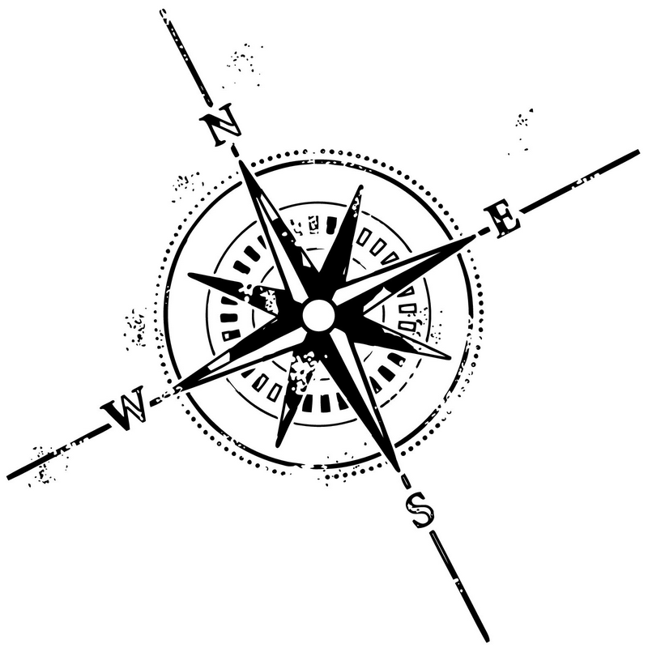
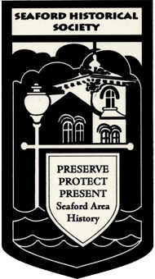
Maps
You may have used the maps feature on your smartphone or computer, but there are many different types of maps.
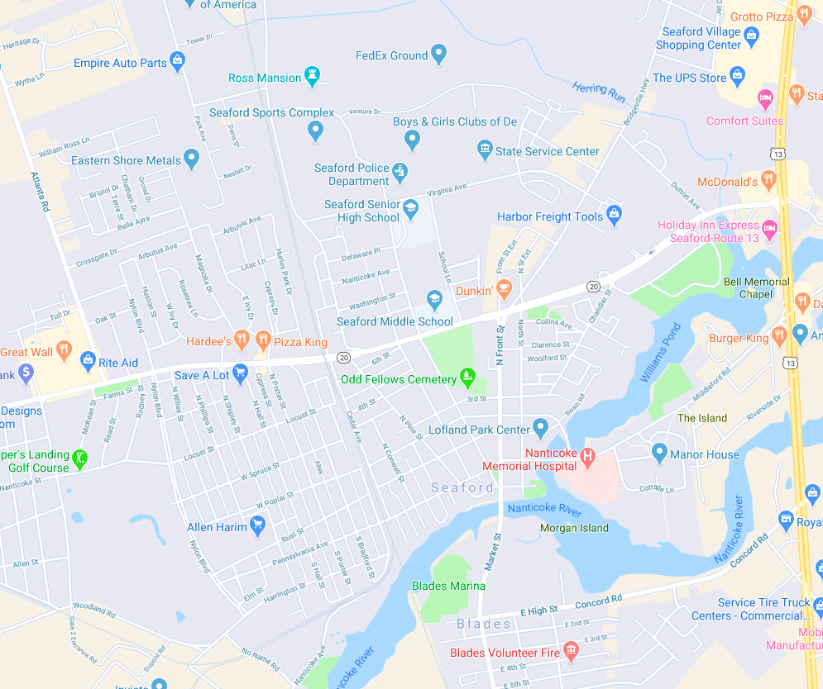
This is from a smartphone and shows street names and the location of some businesses. How is this type of map useful?

From the late 1800’s through the early 1900’s the Sanborn Company made “Fire Insurance Maps” to help companies set prices for policies.

There are always commercials on TV for homeowners’ and car insurance (“Safe drivers save 40%”). What is insurance?

Two Sanborn Maps of Seaford are found on pages 3 and 4. List three things that you notice about the maps:
1.
2.
3.

Part of the key for the map says that wooden buildings are shown in yellow and brick houses in red. Why would this information be important to an insurance company?
Intermediate
Lesson 1.6

Sanborn Maps had lots of information and they can be studied for hours; some people even use them for decoration. If you want to get a better look, follow the link below each.

Use the maps to list three things that changed in Seaford from 1885 to 1910:
1.

2.

3.

Pick one of these and say why you think the changed happened.

Look at the intersection of High Street and Market Street. What changed between 1885 and 1910?

What is that intersection like today?

Are there any buildings on these maps that are still standing today? If you’re not sure, ask someone who might know.

Seaford, Del. 1885
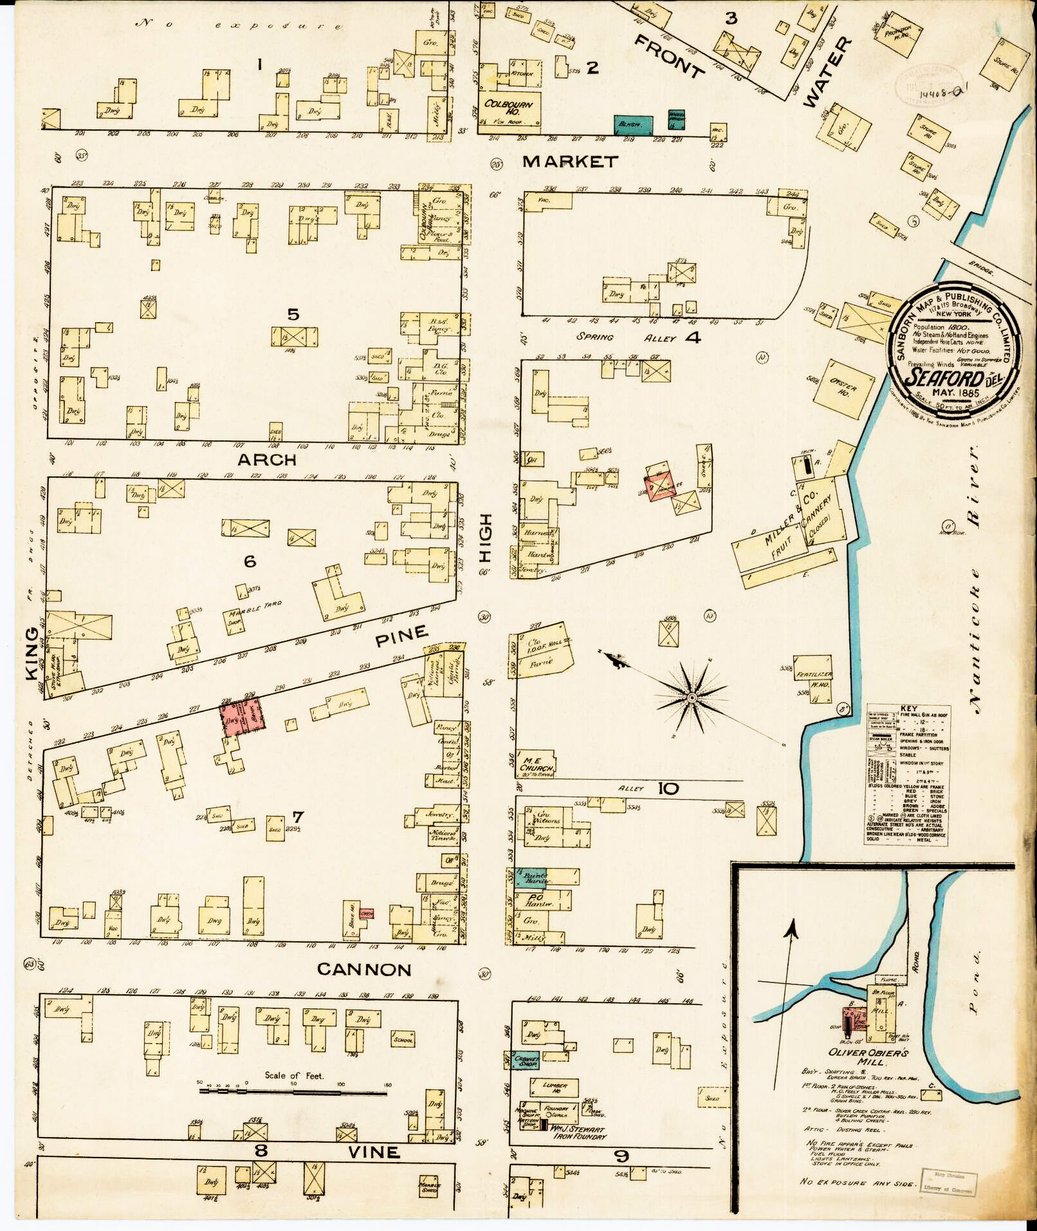
See a high-resolution image at: https://www.loc.gov/resource/g3834sm.g012231885/
Seaford, Delaware 1910
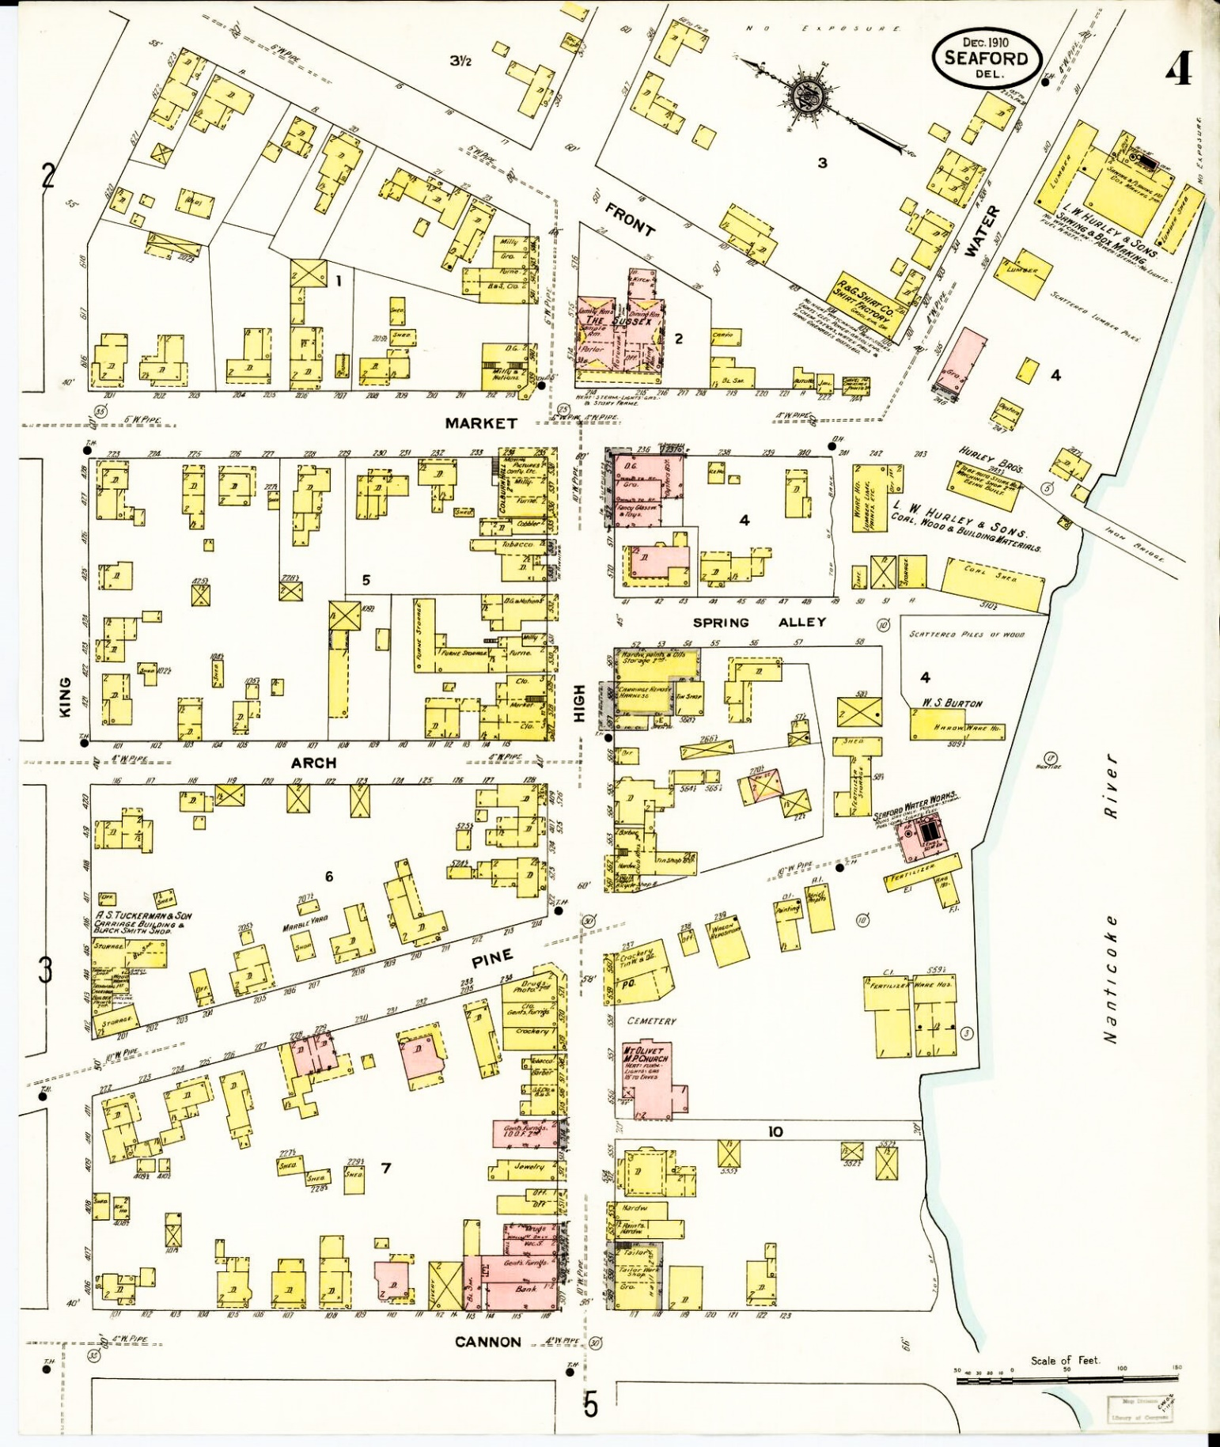
See a high-resolution image at: https://www.loc.gov/resource/g3834sm.g012231910/?st=gallery
You can see many more maps and images of Seaford and other towns at the Library of Congress website.

